Project Documentation

## RYTHAMIC TUNE

# Introduction

## Project Title: RYTHAMIC TUNE

**Team ID:NM2025TMID41036**

**Team Leader:** Name & Mail id: MUTHU KRISHNAN A || 24bca31acas@gmail.com

## Team Members:

* + - Name & Mail id: LAKSHMI NARAYANAN N S || 24bca26acas@gmail.com
    - Name & Mail id: GOKUL V || 24bca10acas@gmail.com
    - Name & Mail id: PAVAN KRISH P || 24bca35@gmail.com

# Project Overview

**Purpose:** SB Works connects clients and freelancers through project postings, bidding, and real-time communication.

## Features:

* + - Project posting and bidding
    - Secure chat system
    - Feedback and review system
    - Admin control panel

# Architecture

**Frontend:** React.js with Bootstrap and Material UI

**Backend:** Node.js and Express.js managing server logic and API endpoints

**Database:** MongoDB stores user data, project information, applications, and chat messages

# Setup Instructions

## Prerequisites:

* + - Node.js
    - MongoDB
    - Git
    - [React.js](http://react.js)
    - Express.js **–** Mongoose **–** Visual Studio Code

## Installation Steps:

# Clone the repository git clone

# Install client dependencies cd client npm install

# Install server dependencies cd

../server npm install

# Folder Structure

SB-Works/

|-- client/ # React frontend

| components/ L pages/

| server/ # Node.js backend

| routes/

| models/

| controllers/

# Running the Application

## Frontend:

cd client npm start • **Backend:**

cd server npm start

**Access:** Visit [http://localhost:3000](http://localhost:3000/)

# API Documentation

## User:

* + - /api/user/register
    - /api/user/login

## Projects:

* **Chats:**
* /api/projects/create
* /api/projects/:id

• **Applications:**

/api/apply

* /api/chat/send
* /api/chat/:userId

# Authentication

* + - JWT-based authentication for secure login
    - Middleware protects private routes

# User Interface

* + - Landing Page
    - Freelancer Dashboard
    - Admin Panel
    - Project Details Page

# Testing

* + - Manual testing during milestones
    - Tools: Postman, Chrome Dev Tools

**Screenshots or Demo**

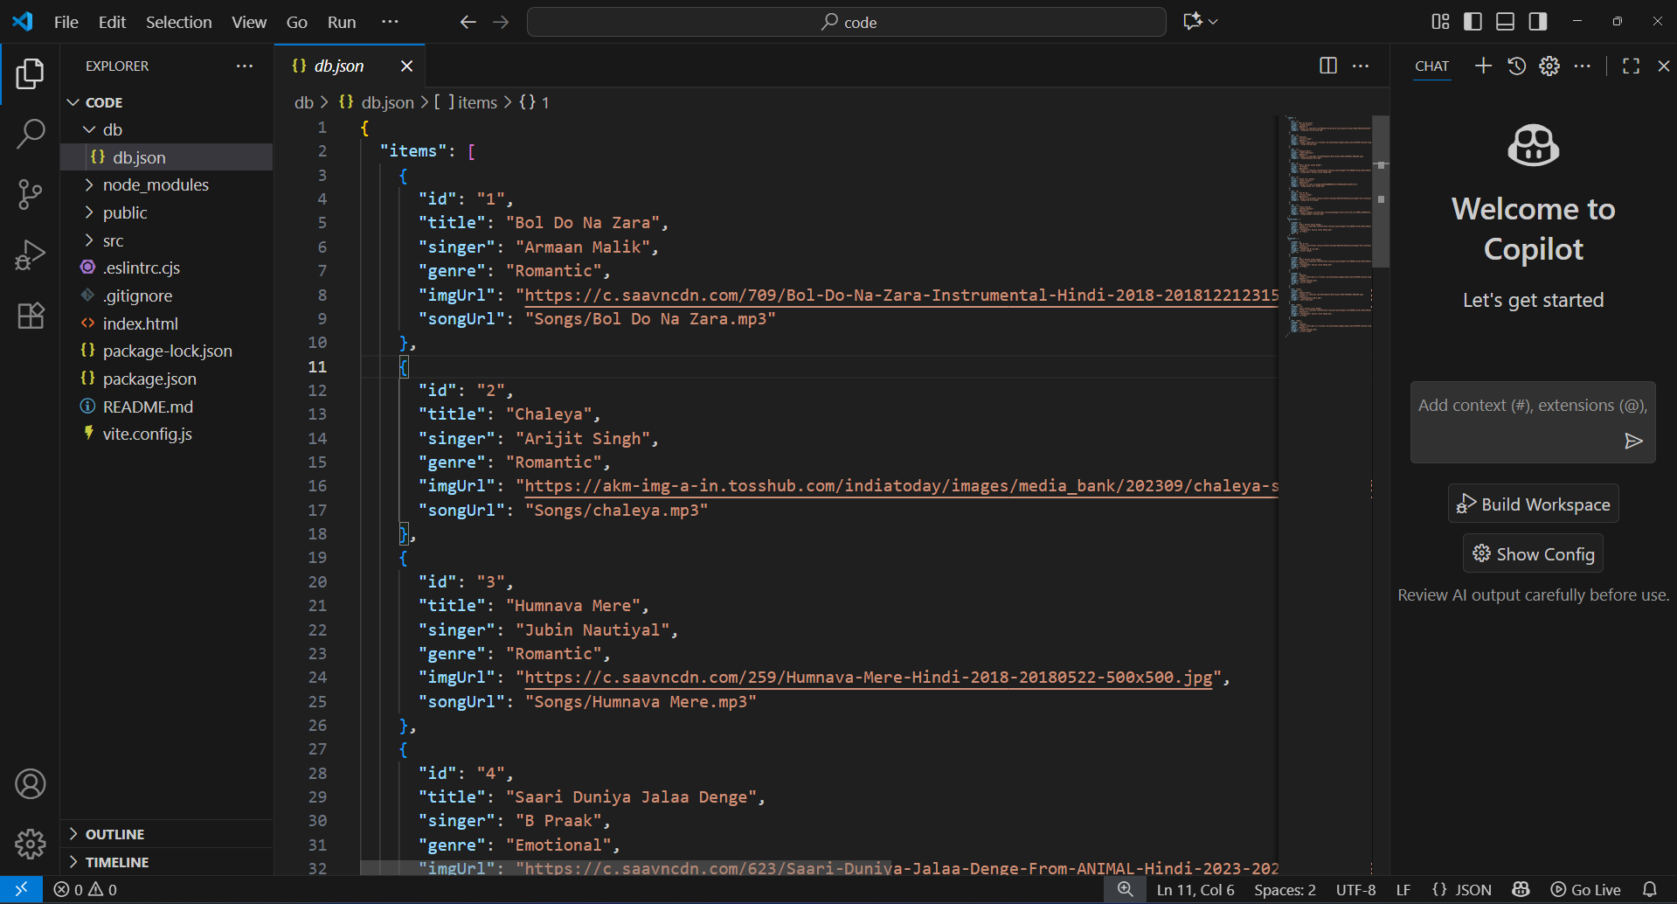

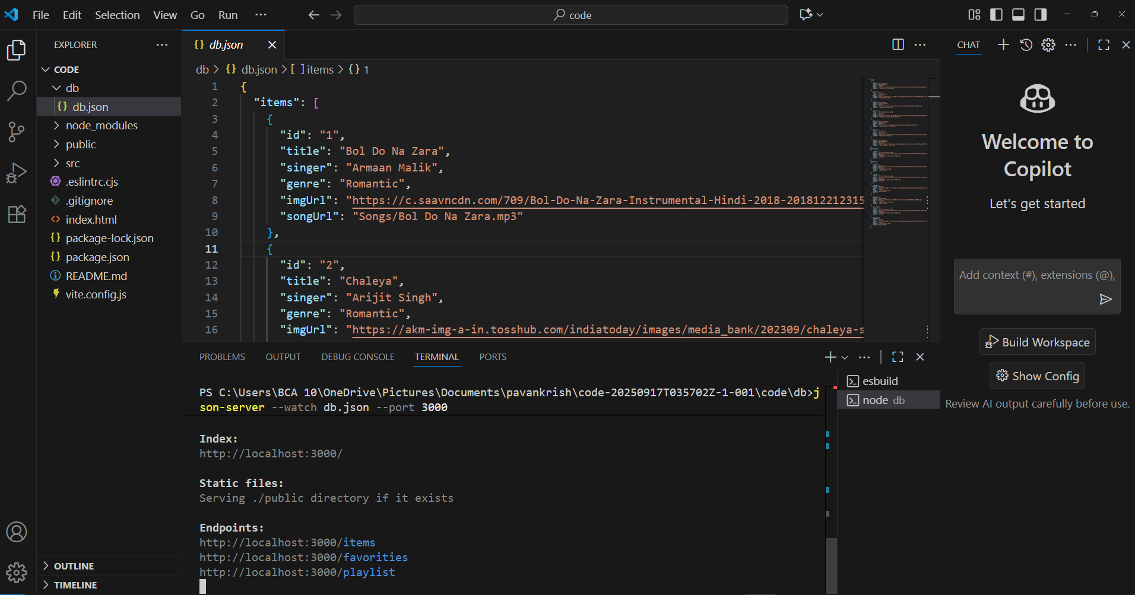

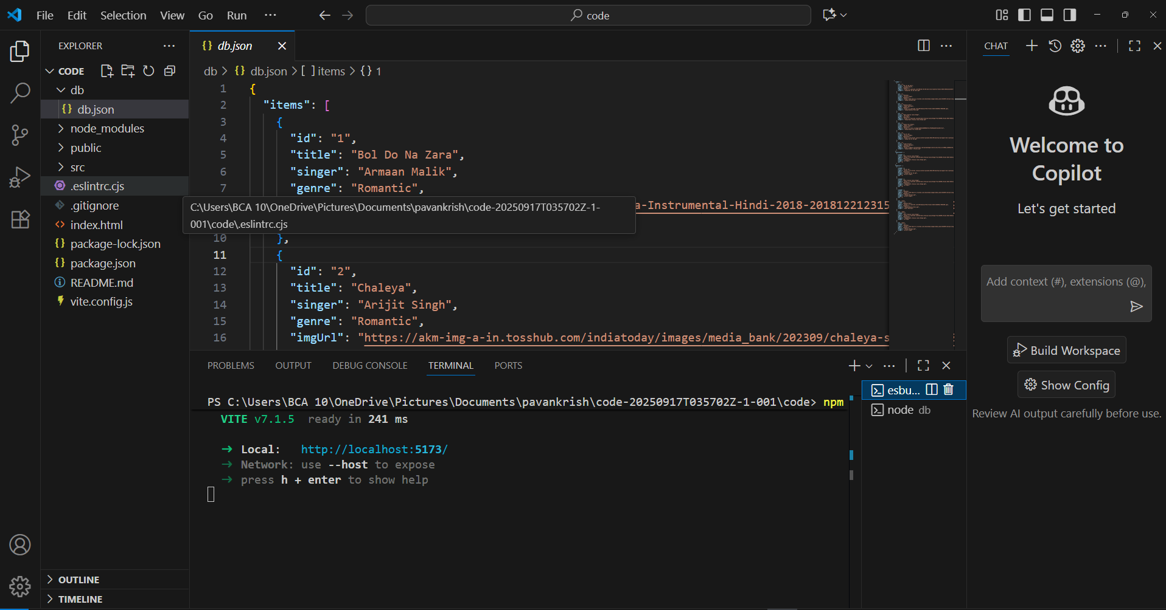

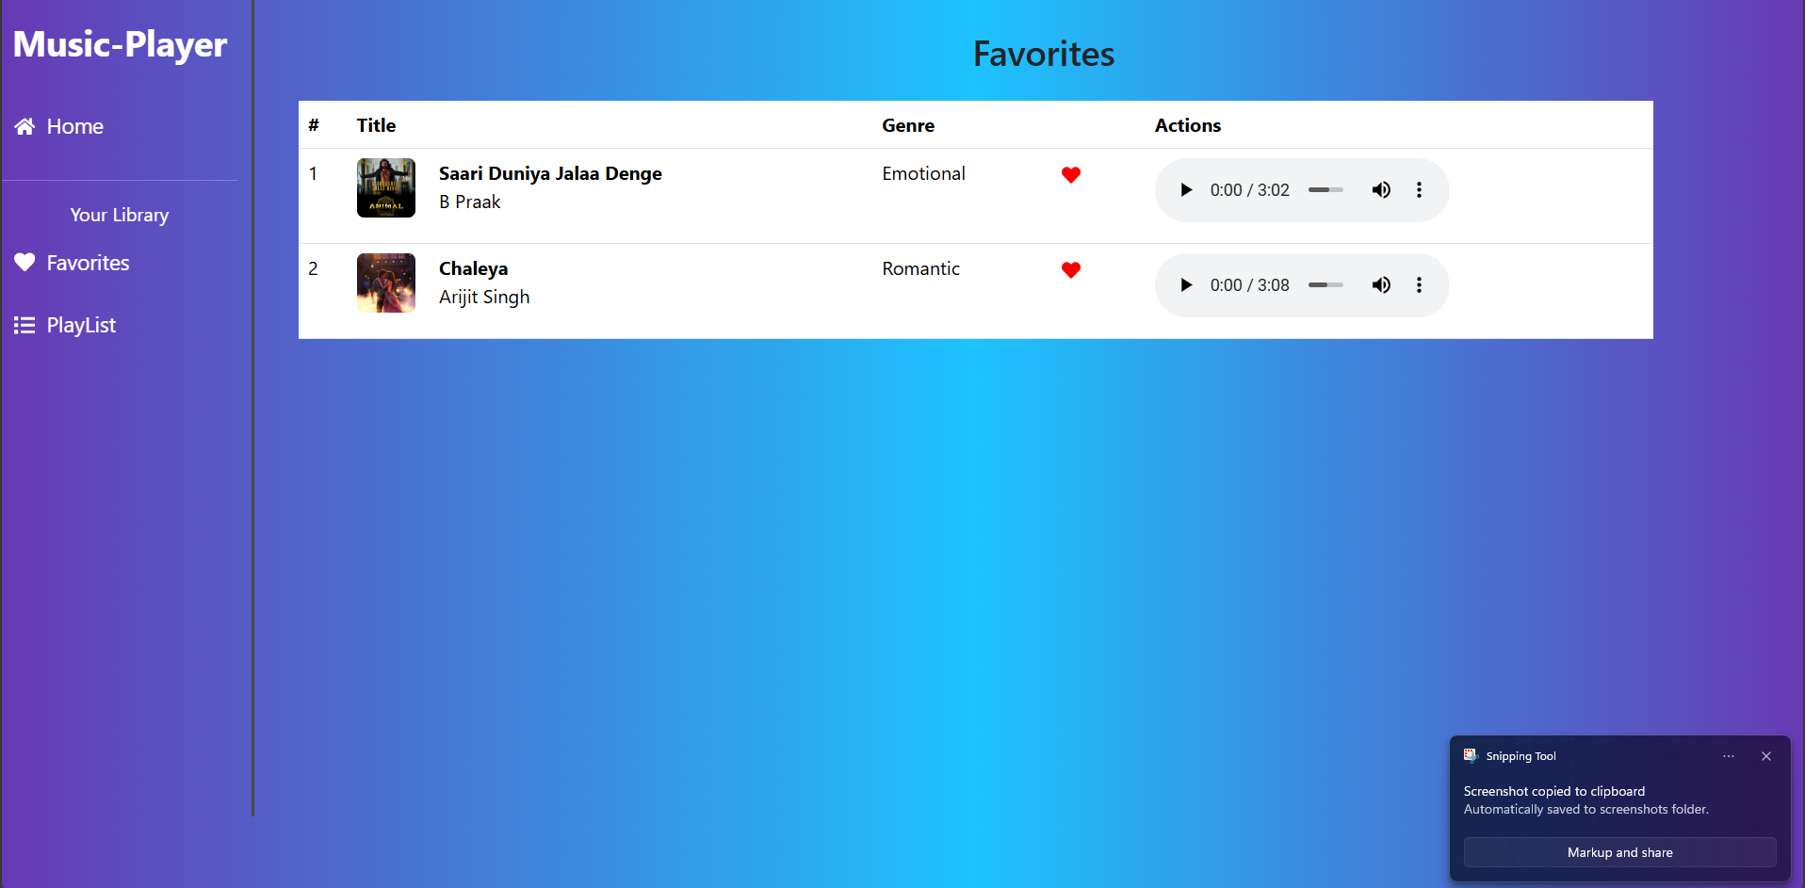

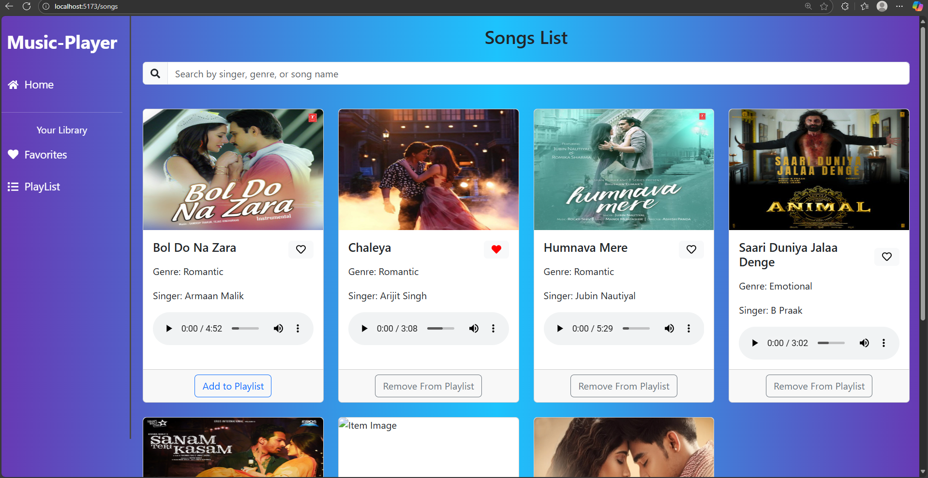

**Known Issues**

* Implementing and installing in node js comment on npm audit for challenge
* Downloading packages and set in correct directory

**Future Enhancements**

* The system can be enhanced by implementing Artificial Intelligence (AI) and Machine Learning (ML) techniques to analyze user preferences, listening patterns, and mood. This would allow the application to automatically adapt to the user’s taste in music and provide personalized song recommendations. By learning from user interactions, the system can push songs that match or expand their liking, thereby improving user engagement and satisfaction.

## 